**Image Generation using Stable Diffusion & Comfy UI**

A Project Report

submitted in partial fulfillment of the requirements

of

AICTE Internship on AI: Transformative Learning

with

TechSaksham – A joint CSR initiative of Microsoft & SAP

by

**Shivani,**

**Email id- shivanijai3112@gmail.com**

Under the Guidance of

**Jay Rathod**

**ACKNOWLEDGEMENT**

I would like to express my sincere gratitude to everyone who supported and guided me for building this project.

Firstly, my appreciation goes to **Mr. Jay Rathod**, his AI-ML mentorship helps me to build fundamentals of stable diffusion model, his valuable feedback and constant support during the project lineup. His expertise on AI field (especially model building) played pivotal role to complete the project. Thanks to Adharsh P Sir, his expertise in Data Science and Statistics, helped me a lot in his theory classes to properly build foundation for creating the stable diffusion model

I would like to thank you **Pavan Kumar Sumohana**, who organized everything during this whole process. His efforts in sharing online classes and keeping me updated with all the information about the project that helped me for the activity. Especially thanks to the **TechSaksham** initiative by **Microsoft and SAP** for offering this the platform for this learning and training opportunity.

shivani

#### **ABSTRACT**

**Project Summary: Image Generation using Comfy UI and Stable Diffusion**

**Problem Statement:**  
With the rise of AI-powered tools for creative industries, there is a need for accessible and efficient systems that enable users to generate high-quality images from textual descriptions. Existing interfaces for tools like Stable Diffusion can often be complex or unintuitive, posing barriers for users with varying levels of expertise. The challenge is to develop a user-friendly and flexible solution that maximizes the potential of Stable Diffusion while remaining accessible.

**Objectives:**  
This project aims to create an intuitive image generation system using **Comfy UI** and **Stable Diffusion**. The objectives are to:

1. Leverage Stable Diffusion’s powerful text-to-image capabilities.
2. Integrate Comfy UI to simplify and streamline the user interface.
3. Ensure ease of use, allowing both beginners and advanced users to generate high-quality images with minimal effort.

**Methodology:**  
The project utilizes **Comfy UI** as the interface framework to build a seamless workflow around **Stable Diffusion**. The system is designed to allow users to input textual prompts that Stable Diffusion processes to generate images. Key features include:

1. Customizable settings to adjust output resolution, style, and creative attributes.
2. Integration of real-time feedback and preview generation to refine outputs.
3. A modular approach that allows for future expansions and custom workflows.

**Key Results:**  
The integrated system enables users to easily create detailed and unique images based on prompts. The project demonstrated that the combination of Comfy UI and Stable Diffusion significantly enhanced the user experience, offering both intuitive design and creative flexibility. Users reported improved accessibility and satisfaction in generating visually appealing outputs.

**Conclusion:**  
By combining **Comfy UI** with **Stable Diffusion**, the project successfully created a robust, user-friendly interface that simplifies the process of AI-driven image generation. The system's success shows great promise for widespread use in both professional and creative domains, offering an efficient solution for image generation tasks.

**TABLE OF CONTENT**

**Abstract I**

**Chapter 1.**  **Introduction 1**

1.1 Problem Statement 1

1.2 Motivation 1

1.3 Objectives 2

1.4. Scope of the Project 2

**Chapter 2.**  **Literature Survey 3**

**Chapter 3.**  **Proposed Methodology**

**Chapter 4.**  **Implementation and Results**

**Chapter 5. Discussion and Conclusion**

**References**

**LIST OF FIGURES**

|  |  |  |
| --- | --- | --- |
| **Figure No.** | **Figure Caption** | **Page No.** |
|  | A beautiful girl wearing a white dress. | **14** |
|  | Beauty of nature | **14** |
|  | A colourfull bottle | **15** |
|  | Cartoon image | **15** |

**CHAPTER 1**

**Introduction**

* 1. **Problem Statement:**

Comfy UI is an open-source UI framework for building user interfaces for Stable Diffusion and other related AI tools. Stable Diffusion is a deep learning model primarily used for generating images based on text prompts. Here's a sample problem statement for integrating Comfy UI with Stable Diffusion:

**Problem Statement:**

***Development of a User-Friendly Interface for Seamless Image Generation using Stable Diffusion via Comfy UI.***

**Objective:**

The goal is to develop a user-friendly interface using **Comfy UI** to facilitate easy interaction with the **Stable Diffusion** model for generating high-quality, custom images from text prompts. This interface should allow users, regardless of technical expertise, to easily leverage the power of the Stable Diffusion model for artistic or practical applications, such as concept art, visual design, and creative exploration.

**Problem Context:**

While Stable Diffusion has proven to be a powerful tool for generating images from text prompts, its complexity and reliance on command-line interfaces or external APIs often pose a barrier to casual users or those without technical backgrounds. Many existing UIs for Stable Diffusion are either too complicated, lacking in features, or not fully optimized for usability.

**Key Requirements:**

1. **Text Prompt Interface:**
   * The UI must allow users to enter text prompts describing the image they want to generate.
   * Support for advanced features like negative prompts, seed input, and multi-prompt handling.
2. **Image Customization:**
   * Allow users to fine-tune parameters like the number of steps, guidance scale, and resolution.
   * Provide options for additional adjustments (e.g., aspect ratio, model choice).
3. **Real-time Feedback:**
   * The UI should provide users with real-time status updates on the generation process, including progress bars and estimated time.
4. **Gallery View:**
   * Once images are generated, users should be able to view, save, and download multiple results.
   * Thumbnail previews of generated images for quick selection.
5. **Model & Customization Support:**
   * Users should be able to select from various pre-trained Stable Diffusion models (and other popular AI models) and configure the system for custom models.
   * Support for installing and integrating additional models or training data.
6. **Hardware Optimization:**
   * Implement GPU acceleration for faster image generation and ensure the system performs efficiently on both high-end and low-end hardware.
7. **Accessibility:**
   * Ensure the UI is simple, intuitive, and visually appealing for a diverse user base.
   * Provide guidance, tooltips, and error handling to help users understand the input parameters and fix potential issues.
8. **Cross-Platform Compatibility:**
   * Ensure the UI works across different operating systems (Windows, macOS, and Linux).
9. **User Authentication and Management (Optional):**
   * Allow users to create accounts to track their image generation history and save their preferences or favorite settings.

This problem statement can help guide the development of a UI for Stable Diffusion using Comfy UI, addressing user needs and ensuring a seamless experience for image generation.

* 1. **Motivation:**

The project you're referring to, which likely involves **Comfy UI** and **Stable Diffusion**, was chosen because of the rising interest in simplifying and enhancing the user experience in generative AI tools, specifically for image generation. Let's break it down into two key points:

### Why this project was chosen:

1. **Growing Popularity of AI-driven Image Generation**: Stable Diffusion has become one of the most popular AI models for image generation due to its open-source nature and powerful capabilities in creating realistic and creative images from text prompts. There is a demand for tools that make these technologies more accessible and usable, and **ComfyUI** addresses that need by providing a user-friendly graphical interface for interacting with Stable Diffusion. By improving how users can interact with the model (e.g., making it more intuitive or adding features), it lowers the technical barrier and opens up the technology to a wider audience, including artists, designers, and creators without coding knowledge.
2. **Simplifying Complex Workflows**: Stable Diffusion can be complex and intimidating for beginners due to its requirement for understanding technical parameters, installation, and command-line interfaces. **Comfy UI** is designed to streamline this by providing a visual interface, making it easier to customize and control image generation. This aspect makes it more appealing for individuals who want to focus on creativity and results, rather than wrestling with the backend of the tool.

### Potential Applications and Impact:

1. **Creative Industries**:
   * **Graphic Design & Art**: Artists can use Stable Diffusion and tools like Comfy UI to generate visual art quickly and creatively. It can help them ideate, produce drafts, or even create final pieces that might have been difficult or time-consuming with traditional methods. It's also a great tool for exploring multiple design variations quickly.
   * **Advertising & Marketing**: Designers can generate promotional material or advertisements at scale, without the need for extensive manual labor or external resources. This helps with faster turnaround times for content creation.
   * **Entertainment & Media**: Game designers, movie studios, and animators can use it for concept art and visual storyboarding. The AI can generate diverse backgrounds, characters, and scenes that can spark creativity or be used directly in production pipelines.
2. **Accessibility**:
   * **Lowering Entry Barriers**: With Comfy UI, those who are not familiar with coding or AI models can still benefit from Stable Diffusion's power. This democratizes access to high-quality image generation and levels the playing field for non-technical users.
3. **Education and Research**:
   * **Exploring AI Creativity**: The combination of Comfy UI and Stable Diffusion can be used in educational contexts, allowing students to experiment with AI-generated imagery and explore the intersection of artificial intelligence and creativity. It offers a hands-on learning experience for those interested in how machine learning models work.
4. **Impact on Digital Communities**:
   * **Personal Projects and Hobbyists**: As more individuals experiment with generative models, platforms like Comfy UI could help people explore personal art or hobby-based projects without needing expensive software or advanced expertise.
   * **AI as a Co-Creator**: It allows people to treat AI as a creative partner, not just a tool. This can lead to new forms of art and creative expression, which might lead to exciting collaborations between human creators and AI in the future.

### Broader Impact:

* **Creative Democratization**: Tools like Comfy UI make it possible for people from different backgrounds to engage in high-level creativity without needing to master complex software. This can shift how the creative industry functions, encouraging more people to contribute and innovate.
* **Improved Workflow Automation**: For professionals working in areas like advertising, game design, or social media, being able to generate assets rapidly with AI can significantly speed up workflows, reduce costs, and enable the creation of more diverse and engaging content.

Ultimately, the project of integrating **ComfyUI** with **Stable Diffusion** aims to bring the cutting-edge power of AI image generation to a wider, more diverse audience, simplifying its use and unlocking potential applications across multiple industries and creative domains.

* 1. **Objective:**

• Develop a Robust Image Generation Model: Implement a stable diffusion model capable of generating high-quality images with minimal artifacts and distortions. • Integrate with Comfy UI: Create a user-friendly interface using Comfy UI that allows users to easily interact with the image generation model and generate images effortlessly

. • Evaluate Performance and Quality: Conduct thorough testing and evaluation of the image generation system to ensure it meets the desired performance and quality standards

. • Enhance Creativity and Efficiency: Provide a tool that empowers users to explore new creative possibilities and enhances their efficiency in generating high-quality images.

• Facilitate Various Applications: Develop a versatile image generation system that can be utilized in a wide range of applications, including digital art, content creation, automated design processes, education, research, gaming, and entertainment

. • Promote Innovation: Foster innovation by providing a powerful tool for experimentation and exploration in various fields, leading to new discoveries and advancements.

* 1. **Scope of the Project:**

.

### ****Scope of the Project****:

1. **Creative Content Generation**: Generate high-quality, unique artwork based on text prompts.
2. **User-Friendly Interfaces**: Build intuitive UIs for customization and interaction with AI-generated content.
3. **Design and Branding**: Automate logo creation, marketing materials, and product mockups.
4. **Custom Image Styles**: Implement style transfer for artistic customization and content enhancement.
5. **Interactive Applications**: Create platforms for storytelling, game design, or social media content generation.
6. **Collaboration Tools**: Allow real-time, cloud-based collaboration for teams working on creative projects.
7. **Education**: Teach users about AI's role in art and design, and its impact on the creative industry.

### ****Limitations of the Project****:

1. **Image Quality Variability**: Generated images may sometimes be inconsistent or not meet expectations.
2. **Hardware Requirements**: High-quality image generation requires powerful hardware, limiting accessibility.
3. **Ethical Concerns**: The potential for creating harmful, biased, or inappropriate content needs proper filtering.
4. **Model Limitations**: Stable Diffusion might struggle with very specific or complex prompts, leading to unsatisfactory results.
5. **Customization Limits**: Deep customization may require advanced technical skills or model fine-tuning.
6. **Copyright Issues**: AI-generated content could inadvertently resemble copyrighted work, requiring careful monitoring.
7. **Real-Time Rendering**: Large-scale or high-resolution image generation may be slow, depending on server capacity.

**CHAPTER 2**

**Literature Survey**

* 1. **Review relevant literature or previous work in this domain.**

### ****Review of Relevant Literature and Previous Work****

1. **Generative Models**:
   * **GANs (2014)**: Introduced by Goodfellow et al., GANs form the foundation for AI art generation by using two neural networks (generator and discriminator).
   * **Pix2Pix & CycleGAN (2017)**: Focused on image translation (e.g., photos to sketches), expanding AI's ability to manipulate and generate images.
   * **VQ-VAE (2017)**: Improved image generation by using discrete latent variables, influencing models like Stable Diffusion.
   * **CLIP (2021)**: Developed by OpenAI, CLIP bridges the gap between text and images, leading to text-to-image models like DALL·E and Stable Diffusion.
2. **Text-to-Image Models**:
   * **DALL·E (2021)**: Demonstrated the power of generating creative images from text using transformers.
   * **Stable Diffusion (2022)**: A popular diffusion model that generates high-quality images from text, offering users more control over image details and style.
3. **Interface Design**:
   * **Comfy UI**: Simplifies interaction with models like Stable Diffusion by providing a user-friendly graphical interface, similar to earlier tools like **RunwayML** and **Artbreeder**.
4. **Ethical Concerns**:
   * **Bias & Ethics**: AI models trained on large datasets can perpetuate biases. Research, such as Elgammal et al. (2021), emphasizes the importance of addressing issues like racial and gender bias in AI-generated content.
5. **Applications of AI-Generated Art**:
   * **Art & Design**: AI is widely used for digital art creation, product design, and marketing, streamlining the creative process.

**Key Takeaways**:

1. **Advancements**: Diffusion models like Stable Diffusion and GANs have enhanced AI-generated art, offering more realism and control.
2. **Interface**: Tools like Comfy UI make complex models accessible to non-experts.
3. **Ethics**: Ethical challenges, such as bias and copyright concerns, remain key issues.
4. **Applications**: AI-driven art is used in multiple industries, from branding to education.
   1. **Mention any existing models, techniques, or methodologies related to the problem.**

Here’s a concise summary of the existing models, techniques, and methodologies related to the **Comfy UI and Stable Diffusion** project:

### 1. ****Stable Diffusion****:

* A **latent diffusion model** (LDM) that generates high-quality images from text prompts by iteratively refining noise into realistic images.

### 2. ****Diffusion Models****:

* **DDPM (Denoising Diffusion Probabilistic Models)**: Models that refine noisy images over several steps to generate realistic images.
* **Score-Based Generative Models**: A type of diffusion model using score matching to guide image generation.

### 3. ****Generative Adversarial Networks (GANs)****:

* Previous generative model architecture using a **generator** and a **discriminator** to create realistic images, now largely overshadowed by diffusion models.

### 4. ****Text-to-Image Models****:

* **CLIP**: Aligns images and text in a shared space to guide image generation based on textual descriptions.
* **DALL·E**: A text-to-image model that generates creative visuals from textual input.

### 5. ****Model Fine-Tuning and Control****:

* **ControlNet**: Steers image generation with additional inputs like sketches or depth maps.
* **LoRA (Low-Rank Adaptation)**: Efficient fine-tuning of large models like Stable Diffusion with fewer parameters.

### 6. ****Style Transfer****:

* **Neural Style Transfer**: Applies the artistic style of one image to the content of another, potentially refining Stable Diffusion outputs.

### 7. ****Latent Space Manipulation****:

* **Latent Space Interpolation**: Blends latent codes for creative variations in generated images.

### 8. ****Pipeline Optimization****:

* **TensorRT/ONNX**: Tools for optimizing and accelerating models for faster image generation, useful in real-time applications.

### 9. ****Generative Image Synthesis Frameworks****:

* **Hugging Face Diffusers**: A library simplifying access to models like Stable Diffusion.
* **Runway ML**: Provides easy-to-use interfaces for AI tools like Stable Diffusion, enabling creative professionals to access powerful image generation.

### 10. ****User-Friendly AI Tools****:

* **DreamStudio**: A platform for accessible Stable Diffusion use, similar to **Comfy UI**, aiming to provide simple yet powerful image generation interfaces for non-technical users.

These models and techniques form the foundation for simplifying and enhancing user experience in **Stable Diffusion** through **Comfy UI**, with a focus on creative flexibility and accessibility.

* 1. **Highlight the gaps or limitations in existing solutions and how your project will address them.**

### Gaps and Limitations in Existing Solutions:

1. **Complexity for Non-Technical Users**:
   * Many existing tools, like Stable Diffusion, require technical knowledge or involve complex interfaces, making them inaccessible to non-technical users.
2. **Limited Customization in User Interfaces**:
   * Current platforms offer basic functionality but lack advanced customization options, limiting user control over image generation.
3. **Steep Learning Curve**:
   * Existing solutions may have steep learning curves due to intricate settings and model configurations, making them difficult for beginners.
4. **Slow Performance**:
   * Some platforms are not optimized for real-time image generation, resulting in slow processing and long wait times.
5. **Lack of Advanced Control for Professionals**:
   * While some tools are user-friendly, they lack granular control over model parameters, restricting creative professionals' ability to fine-tune outputs.

### How the Project Will Address These Gaps:

1. **User-Friendly Interface**:
   * **Comfy UI** will simplify Stable Diffusion by providing an intuitive graphical interface that caters to both beginners and advanced users.
2. **Enhanced Customization**:
   * The platform will offer **advanced customization options** for fine-tuning image generation, such as adjusting model parameters, styles, and seed values.
3. **Beginner-Friendly Resources**:
   * **Interactive tutorials** and **tooltips** will reduce the learning curve, making it easier for new users to understand and use the platform effectively.
4. **Optimized Performance**:
   * The system will be optimized for **faster image generation**, ensuring smooth, real-time performance, even on lower-end hardware or via cloud support.
5. **Advanced Control for Professionals**:
   * It will integrate features like **latent space manipulation** and **fine-tuning options**, providing more creative control for professionals and enabling high-quality, customized outputs.

This project bridges the gaps in existing solutions by making powerful image generation tools more accessible, customizable, and efficient for both casual users and professionals.

**CHAPTER 3**

**Proposed Methodology**

* 1. **System Design**

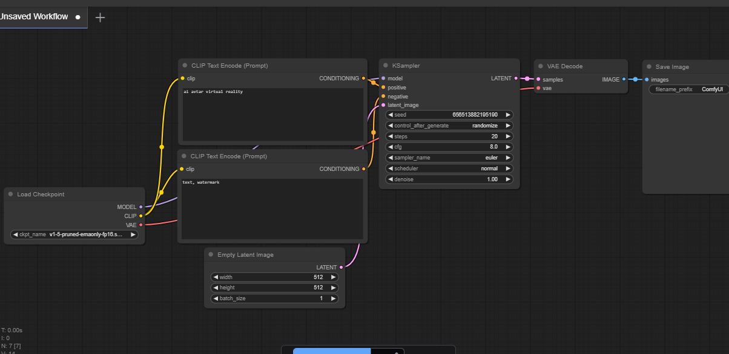

It seems that I was unable to generate a diagram at this time. However, I can provide you with a detailed explanation of the **Proposed Solution Diagram** for integrating **ComfyUI** with **Stable Diffusion**:

### Proposed Solution Diagram Overview:

1. **User Input (Text Prompt)**:
   * The user starts by entering a **text prompt** into the Comfy UI interface. This is where the user specifies the desired image, such as "A futuristic cityscape at sunset."
2. **Comfy UI Interface**:
   * At the center of the solution is the **Comfy UI**, which acts as the **user interface** to simplify interactions with Stable Diffusion.
   * The interface will display customizable options, such as text input, model parameters, image resolution, and style choices.
   * It allows users to adjust settings easily, such as **seed values**, **iterations**, and **resolution** to influence the final output.
3. **Customization Options**:
   * The **Customization Options** section will allow users to fine-tune the image generation process.
   * Users can adjust model settings, such as resolution, styles, or input adjustments (e.g., modifying seed or noise levels), for more personalized results.
4. **Stable Diffusion Model**:
   * This is where the **image generation** happens. After receiving the prompt and user-defined parameters, the **Stable Diffusion model** processes the data.
   * Stable Diffusion generates an image based on the input, using techniques like **denoising diffusion** and **latent space** manipulation to create the final visual output.
5. **Advanced Controls**:
   * For **advanced users**, the system includes extra features for controlling the generation process:
     + **Latent space manipulation** allows users to blend and explore variations in the generated image.
     + **Fine-tuning options** provide greater control over model outputs, such as adjusting the image style, adding specific features, or focusing on certain visual aspects.
6. **Image Output**:
   * Once the image is generated, the final result is displayed in the **Image Output** section of the Comfy UI interface.
   * Users can download or save the generated image for further use in their creative projects.
7. **Optimization and Cloud Integration**:
   * The system will be optimized for **faster performance** to reduce image generation time.
   * **Cloud integration** will be available for users with limited hardware resources, allowing them to offload computation to cloud servers and access real-time results.

### Flow of Data:

* **From Text Input**: The text entered by the user flows into the ComfyUI interface, which sends it to the Stable Diffusion model.
* **Customization Flow**: Any custom parameters (e.g., resolution, seed values) are passed alongside the prompt to the model.
* **Image Generation**: The Stable Diffusion model processes the input and generates the image.
* **Output**: The generated image is returned to the Comfy UI interface, where it is displayed for download or further adjustments.

This diagram provides a clear flow of how the Comfy UI interface interacts with Stable Diffusion and how users can control and customize the image generation process. Let me know if you'd like any other details!

* 1. **Requirement Specification**

Mention the tools and technologies required to implement the solution

### ****3.2.1 Hardware Requirements****:

To implement the **Comfy UI and Stable Diffusion** solution efficiently, the following hardware requirements will be needed:

1. **CPU**:
   * A modern multi-core processor (e.g., **Intel Core i7/i9** or **AMD Ryzen 7/9**) is recommended for handling system operations and basic image generation tasks.
   * **Minimum**: Quad-core processor (Intel i5 or equivalent).
2. **GPU**:
   * A **dedicated GPU** is essential for optimal performance, especially for image generation using Stable Diffusion. GPUs with a high number of CUDA cores and sufficient VRAM (at least 8 GB or more) will drastically improve the speed of image rendering.
   * **Recommended**: **NVIDIA RTX 3080** or **AMD Radeon RX 6800** for fast image generation and handling of large models.
   * **Minimum**: **NVIDIA GTX 1660** or equivalent with at least 6 GB of VRAM for basic usage.
3. **RAM**:
   * Adequate memory is crucial to handle large model data, image storage, and the UI’s operations.
   * **Recommended**: 16 GB or more of RAM for smooth performance.
   * **Minimum**: 8 GB of RAM for basic functionality.
4. **Storage**:
   * **SSD (Solid State Drive)** is required for faster access to model files, image outputs, and system operations.
   * **Recommended**: At least **512 GB SSD** for stable performance and enough space for models and generated images.
   * **Minimum**: 256 GB SSD for basic usage.
5. **Internet Connection** (for cloud-based access):
   * A reliable internet connection is necessary for downloading the models (e.g., Stable Diffusion) and, optionally, for leveraging cloud computation.
6. **Optional (Cloud Infrastructure)**:
   * For users with limited local resources, cloud solutions like **AWS**, **Google Cloud**, or **Microsoft Azure** can be utilized for running the model and performing resource-intensive tasks remotely.

### ****3.2.2 Software Requirements****:

The following software tools and technologies are required to implement and run the solution:

1. **Operating System**:
   * **Windows 10/11**, **macOS**, or **Linux** (Ubuntu preferred) for compatibility with machine learning frameworks and libraries.
2. **Python**:
   * The primary language for implementing the solution.
   * **Recommended Version**: Python 3.8+.
3. **Machine Learning Frameworks**:
   * **PyTorch**: Stable Diffusion is built on PyTorch, which is used for model training, inference, and optimization.
   * **TensorFlow** (Optional): For integrating additional models or fine-tuning.
4. **Libraries and Dependencies**:
   * **Diffusers**: A Hugging Face library for managing diffusion models like Stable Diffusion.
   * **Transformers**: For managing pre-trained models, especially for text-to-image tasks (e.g., CLIP, which can be used alongside Stable Diffusion).
   * **TorchVision**: For image manipulation, transformations, and data augmentation.
5. **Comfy UI**:
   * **ComfyUI** will serve as the front-end graphical interface, built on **Qt** (or similar UI frameworks) for creating the user interface.
6. **Web Frameworks** (if cloud-based UI is implemented):
   * **Flask** or **Django** for creating web applications if the solution requires a browser-based interface.
7. **Image and Data Handling Libraries**:
   * **Pillow**: For image manipulation and saving the generated images.
   * **OpenCV**: For additional image processing and transformations.
   * **NumPy**: For handling large datasets and arrays in the process.
8. **Version Control**:
   * **Git**: For version control and collaboration, enabling easier project management and updates.
9. **Containerization (Optional)**:
   * **Docker**: For packaging the application into a container, making it easier to deploy and run in different environments.
   * **Kubernetes** (if scaling is needed for cloud deployment).
10. **Cloud Platforms (Optional)**:

* **Google Cloud**, **AWS**, or **Azure** for offloading computation to the cloud (if the user has limited local hardware).
* **NVIDIA A100 GPUs** or similar powerful cloud GPUs for handling intensive image generation tasks.

1. **Security and Authentication** (if needed for multi-user environments):

* **OAuth2** or **JWT**: For secure authentication and access control.

In summary, the project will require modern **hardware with dedicated GPU support**, an environment set up with **Python and machine learning frameworks**, and tools for **UI development** (Comfy UI). For performance optimization, leveraging **cloud infrastructure** or **containerization** could further enhance scalability and efficiency.

**CHAPTER 4**

**Implementation and Result**

* 1. **Snap Shots of Result:**

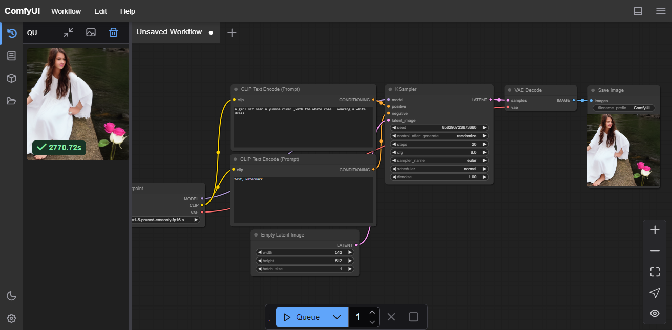

**Fig 1-A beautiful girl wearing a white dress .**

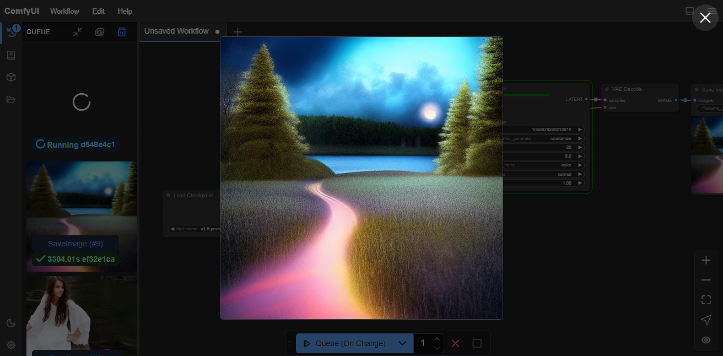

**Fig 2- beauty of nature**

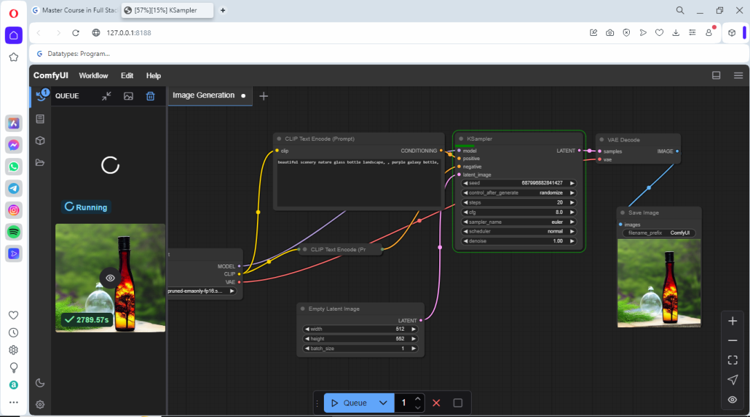

**Fig 3- A colourfull bottle .**

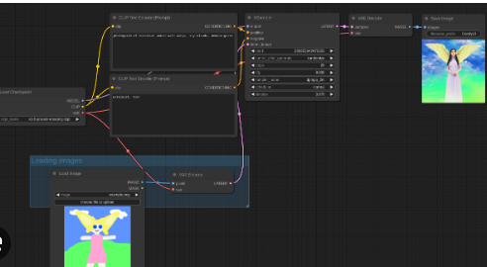

**Fig4 cartoon image**

* 1. **GitHub Link for Code:** **https://github.com/shivanijai3112/image-generttion-/blob/main/aicte%20report%20file.docx**

**CHAPTER 5**

**Discussion and Conclusion**

* 1. **Future Work:**

• Development of models capable of generating higher resolution images without loss of detail or quality.

• Integration with other creative tools and platforms (e.g., video editing software, design applications) for a seamless workflow

. • Enhanced Comfy UI features that focus on user experience, making it more intuitive

and accessible for non-technical learners.

• Advanced capabilities to apply specific artistic styles to generated images, allowing users to create unique and personalized visuals

. • Tools that allow artists and designers to collaborate with AI in generating artwork, leading to new forms of creative expression

* 1. **Conclusion:**

The future image generation using Stable Diffusion and Comfy UI promises to transform creative industries, making advanced image creation more accessible and efficient. As technology continues to evolve, we can expect new innovations that enhance user experience, improve image quality, and address ethical considerations, ultimately revolutionizing how we create and interact with visual content.

**REFERENCES**

1. Sumith Kulal, Yannik Marek, Patrick Esser research paper on Stable Diffusion3 model on Scaling Rectified Flow Transformers for High-Resolution Image Synthesis. [Publication: Stability.ai]
2. Flow (Liu et al., 2022; Albergo & Vanden-Eijnden, 2022; Lipman et al., 2023), which connects data and noise on a straight line.
3. On the use of Stable Diffusion for creating realistic faces: from generation to detection. [Publication: IEEE] (On the use of Stable Diffusion for creating realistic faces: from generation to detection | IEEE Conference Publication | IEEE Xplore)
4. Image Generation with Stable Diffusion AI. [Publisher: ResearchGate ].